

# VIVA - 1

**Graphics and Animation Tools - Lab**

**CSGG 4101**

Name – Rishank Gupta

Roll No. – R100217062

Sap id – 500062486

Course – B. Tech CSE-OSS

Batch – 2

*Under the guidance of…*

Dr.Durgansh Sharma

Associate professor

Department of Cybernetics

School of computer Science (Socs)

**Experiment-1**

**Creation of fruit basket in Blender with a few fruits in it in blender.**

In this experiment we need to create a basket with a few fruits of our choice with the help of blender.

Steps to follow to create a 3D design using Blender

1. Open Blender, and clear everything from the interface which are already there.
2. First, we need to create a basket. For basket go to mesh and take a plane area and then go to mesh again and select a cylinder.
3. Stretch the upper face with respect to base of cylinder and give it a shape of open basket.
4. Extrude the surfaces from all the sides at equal distance to give it a look of moulded surface of basket.
5. Extrude the bottom of the surface around 1.5 pts and give it shape of base of the basket.
6. Do a few changes in the model of basket to give it a realistic approach in better ways.
7. For apples, take the sphere from the mesh and give it a groove from above so, that it looks like the upper portion of apple. Now, put some dots on the apple to give it more realistic look.
8. Now, take the upper portion of apple and extrude it a bit to give the shape of twig which is attached with the apple.
9. Repeat step 7 and 8 multiple times to create a number of apples for the basket.
10. Now, go to shading and then random and fill your selected area with random colours.
11. Go to file and save it as your name and render a few pictures for the display.

**Rendered Picture for reference:**

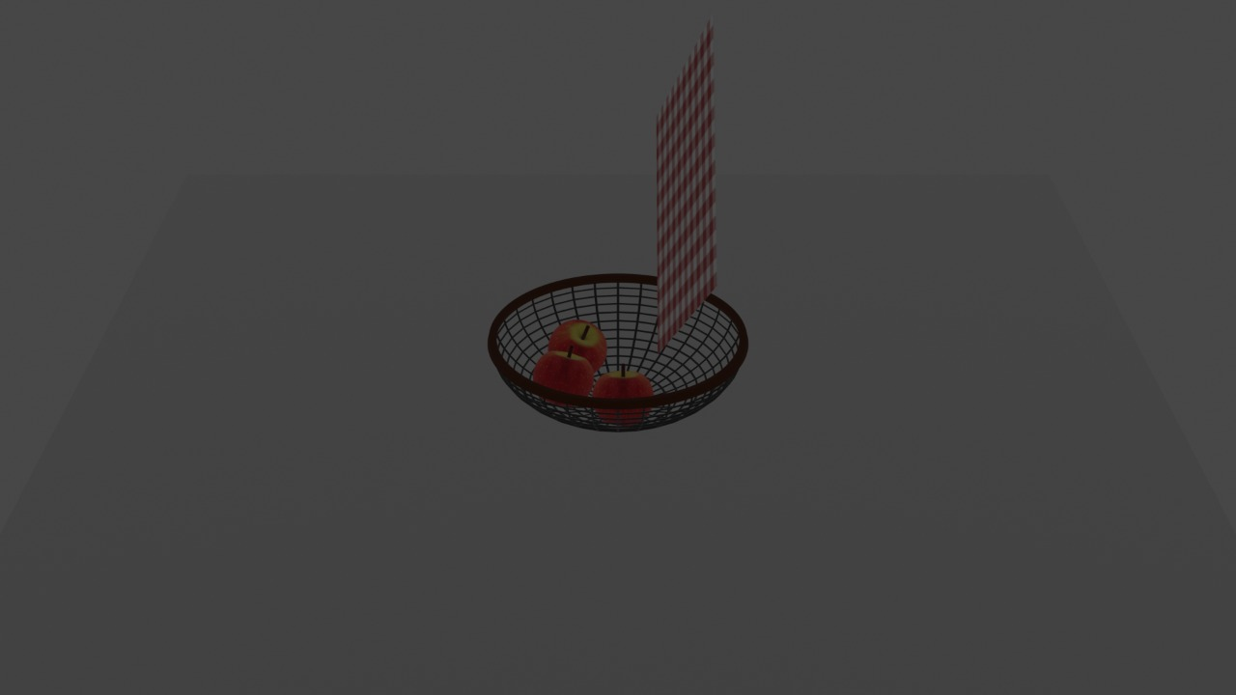

**Experiment-2**

**Creation of basic layout of mobile phone in GIMP.**

In this experiment we need to create a basic layout of mobile with added icons of our choice with the help of GIMP.

1. Take a white background of 1080 x 580 pixels.
2. And put a slightly smaller black ground to create a black border over it.
3. Take a small square in the centre to create the shape of a home button.
4. Import a few buttons for forward and backward and put it side by side of home button.
5. Create a basic layout by putting a few buttons and everything to give it a realistic picture of mobile phone.
6. Save the output. And export it in other location with .XCF extension

**Output Picture for reference:**

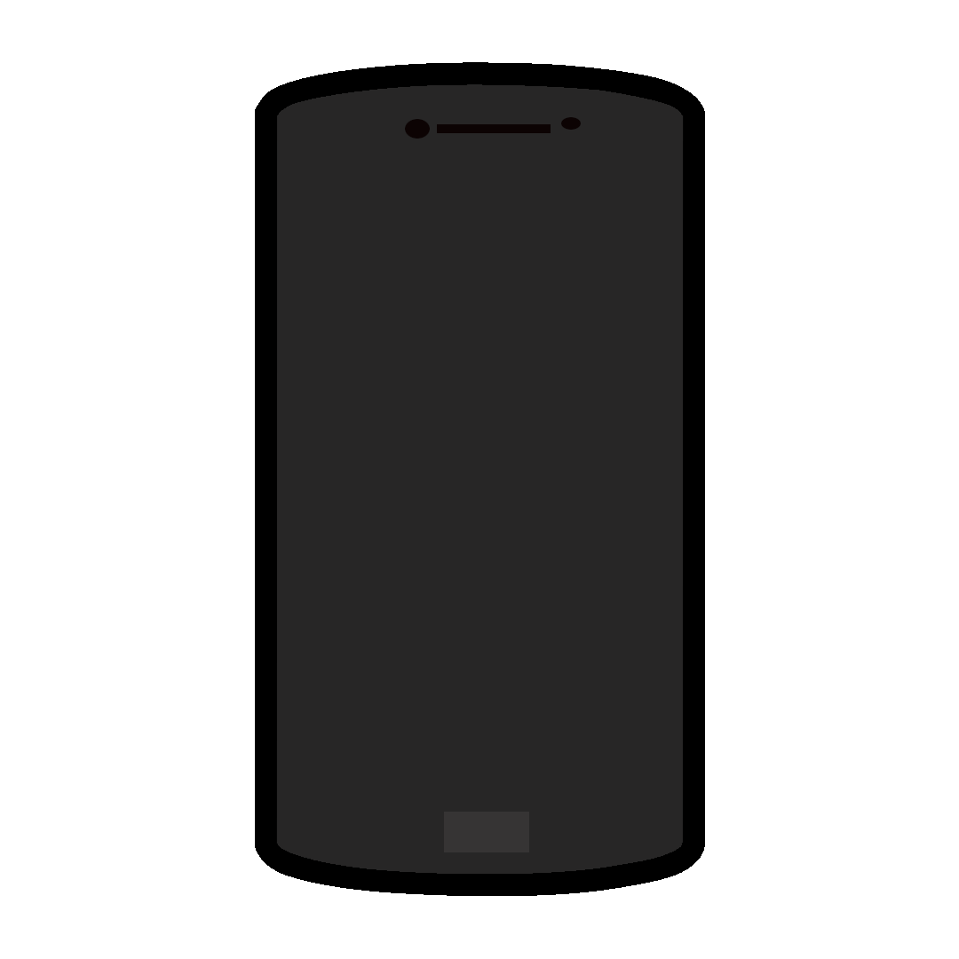

**Link of the Experiments:**

<https://drive.google.com/drive/folders/1MOoYrxbBdfQKMs_tdLUJkX5dE3APaJg5?usp=sharing>